Meeting 16
Course / Class #: CECS 4800
Date: 23 January 2014

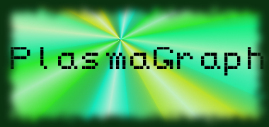
Project Name: PlasmaGraph

Has been done:
1) JMatIO (Matlab reading library for Java) familiarization.
2) New revision of SRS and SDD.
3) Initial version of product GUI. (Via view classes.)

What will be done:
1) Work on SPMP upon complete review by Prof. Ortiz.
2) Start work on product. (Reading functions and basic GUI functionality.
3) Work on SDD. (Various missing diagrams, as well as making adjustments to extremely large diagrams.)

Materials Used: 2x Computers, Internet connections, Microsoft Visio / Dia (Diagramming Tools), Eclipse / NetBeans IDE (Programming Tools).

Group Members:

________________________________
Gerardo A. Navas

________________________________
Daniel Quintini

Professor:

________________________________
Prof. Luis A. Ortiz

